God desires a relationship with us, but it is because of our desire to be independent that we go away from Him. | There’s no one that can love you like He does.  하나님은 당신을 가장 잘 아시며, 당신을 위한 분이십니다  God can heal your brokenness, your hurts, and your pains  오직 하나님만 당신의 모든 아픔과 고통을 치류하실 수 있으십니다  God can heal you in your loneliness, your loss of direction in life  바쁘고 힘든 세상에서도 하나님만이 우리의 마음에 평화를 주실 수 있으십니다  Even when you are going through the greatest stress and difficulties, He can quiet your soul and deliver you  하나님은 하실 수 있으십니다 . . . and He will certainly do it for you  God desires a love relationship with us, but the problem is that we are unfaithful.  우리가 성실하지 못해서 하나님과 깊은 관계를 못 갖는 것입니다.  (Unity by trust) Relationship is about trust, and that is the benefit of your relationship. Trust brings about unity in mind, and enables you to walk together – this is the crux of a relationship – two people trusting each other walking toward the same goals.  God wants us to be trustworthy in this love relationship  (I can recall back before I got married, how I wanted to be in a relationship – to be loved by someone and to also love someone – and I recall praying in my loneliness asking God – just give me! – the right person. From that prayer, God began to work in my life to prepare me to love another person and he is still working on me.)  How about you? Do you want to find the love of your life? Are you ready for a relationship? The issue is with our selfishness (이기적이고) and self-reliance (자기만을 의지한다면). If you are married, and you still led your life for your own, your marriage will not be happy. If you are single and are still self-centered, you will never find a satisfying relationship.  Marriage represents our relationship with God  As the husband is to the wife, Jesus is to the church  In that same relationship with God, are you trustworthy? Are you lovable? Or are you self-centered and seeking maximum pleasure for yourself? Are you ready for a relationship?  (God desires us to separate from the world and come to Him – and you’ll find rest there)
Picture yourself with someone that you deeply love, then imagine them doing the things on the screen . . . that’s how Gomer was.

Share the story of Gomer

You are like that with your busyness

Ultimate point, we too have idols -- things that are more important to God.
In our busy world, we are conditioned to believe work takes top priority -- making money is of the utmost -- and Satan wants such work to really drain us to eventually get us to no longer be focused on God, our true joy and promise.
This is how we do it,
We go after our works, positions, money, fame – thinking they are the things we have to satisfy then God on the side – when truly, it was God who gave us all those things!

This is called prostitution
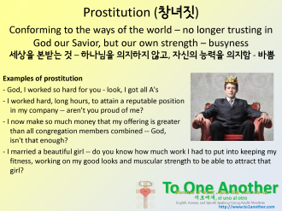 | Point to busyness of society –  Our culture prizes busyness  What you need is to go back to our Savior, our lover, our God. We need to turn away from the priorities of this world and head back to God.
To do that, we need to stop from what we are doing and turn to Him.

From the movie “Amazing Love” where Gomer has sold herself to prostitution. She was caught and now sold as a slave – worthless and full of shame – Hosea redeems her and demonstrates his love for her, even when she has done wrong

(After clip)

And that is amazing love – to love us even in our unfaithfulness. (성실하지 못해도)
He extends that love to you . . .
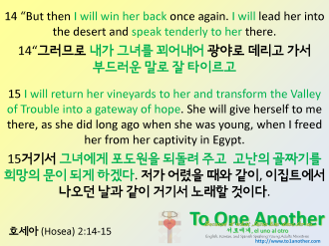
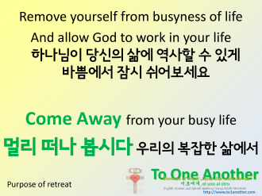 | And this is the purpose of the retreat…  Retreat is a place where we intentionally stop from everything ..  and allow God to do work – to restore us, to nourish, to comfort us, to heal us, to guide us, to put us on the right path – do you want that?  So I ask, come just as you are, with expectation that God will meet you where you are.
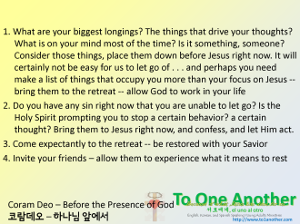 | If you have been stressed out – bring that with you and believe that at the retreat, God will remove that stress  If you have been going through disappointments – bring that just as it is, and believe that God will shed light to what you are going through  If you have been lonely, hurt, or feeling depressed – God is your lover and wants you just as you are… come  4. Protect your marriages – the world will request that you operate on your own. Protect the time you spend with your loved ones – the truth is, if your marriage is an individual thing, your relationship with God is the same – no relation  5. Ladies, practice submission – let your life be attractive so that the men will learn to submit to the Lord. Allow the men to lead and protect the family – this can only happen by your submission  Men, learn to sacrifice, practice putting others before your needs – let your life be attractive so that your wives can feel the love of Jesus that you receive – by your love, there is unity
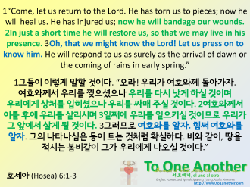

Main idea: we are unfaithful to the Lord because of busyness, let's go back to Him and allow Him to be Lord.

Individual Busyness ... Everything planned out, no time for God to interject. This is Satan's plan for our days. We may think we are doing well as we see money come in or as our fame or confidence increases... But we are becoming more inwardly and away from God

